

KURO – Information for invitation to tender

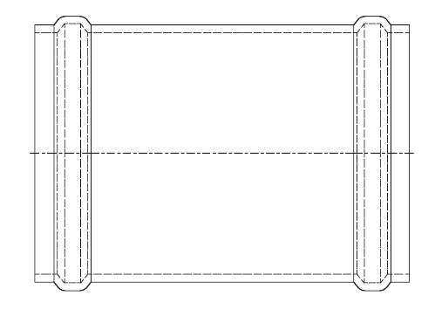
Product:

PP double sealing socket

Information for invitation to tender:

 | Pos:....................... | PP double sealing socket with 2 seal rings
 |  | Colour: black 250 x 8,0 mm / length = 400 mm
 |  | System KURO o. glw. (www.kuro-kunststoffe.de),
 |  | supply and install, as an addition to pos: ...........
 |  | Amount:............Pieces UP: ....... TP: ........

